

Course Code : CSE 404

Course Title : Software Engineering and ISD Laboratory

Project name : Bus ticket booking management system

Experiment no: 07

Experiment name: Application of design pattern (Interface) of bus ticket

**Submitted To**

**Dr. Mohammad Zahidur Rahman**

Professor

**Dr. Md. Humayun Kabir**

Professor

Department of Computer Science & Engineering Jahangirnagar University, Savar.

Group No : 02

Group members :

|  |  |  |
| --- | --- | --- |
| **Sl** | Class Roll | Name |
| 01 | 342 | Tama Shil |
| 02 | 370 | Prokash Maitra |
| 03 | 374 | Mubasher adnan jihad |
| 04 | 375 | Pritam Saha |

**Prokash Mitra**

**Roll:370**

Introduction:

Interface design is a crucial aspect of software development that focuses on creating clear and intuitive user interactions. In this report, we will explore the interface design of an online bus ticket management system, highlighting the considerations, principles, and components that contribute to an effective and user-friendly interface.

1. Importance of Interface Design:

Interface design plays a pivotal role in enhancing user experience and satisfaction. A well-designed interface not only makes the system visually appealing but also ensures ease of use, efficient navigation, and clear communication of information.

1. Design Principles:

* Clarity and Consistency:

Ensure that the interface elements are clear and easily understandable. Consistency in the placement of buttons, icons, and navigation elements across different sections of the application helps users feel comfortable and confident while using the system.

* User-Centric Approach: Design the interface with the user's needs and expectations in mind. Understand the target audience and tailor the interface to their preferences and behaviors. Use user personas and scenarios to guide your design decisions.
* Minimalism and Simplicity: Keep the interface clean and uncluttered. Avoid unnecessary elements that might confuse or overwhelm users. Prioritize essential information and actions, presenting them in a straightforward manner.
* Visual Hierarchy: Use visual cues such as size, color, and placement to establish a clear hierarchy of information. Important elements should stand out while secondary elements remain less prominent.
* Feedback and Responsiveness: Provide instant feedback for user actions. Buttons should respond to clicks, forms should provide validation feedback, and loading states should be indicated. Ensure that the interface is responsive and adapts well to different devices and screen sizes.

**Mubasher Adnan Jihad**

**Roll:374**

Must have booking Software features for client-

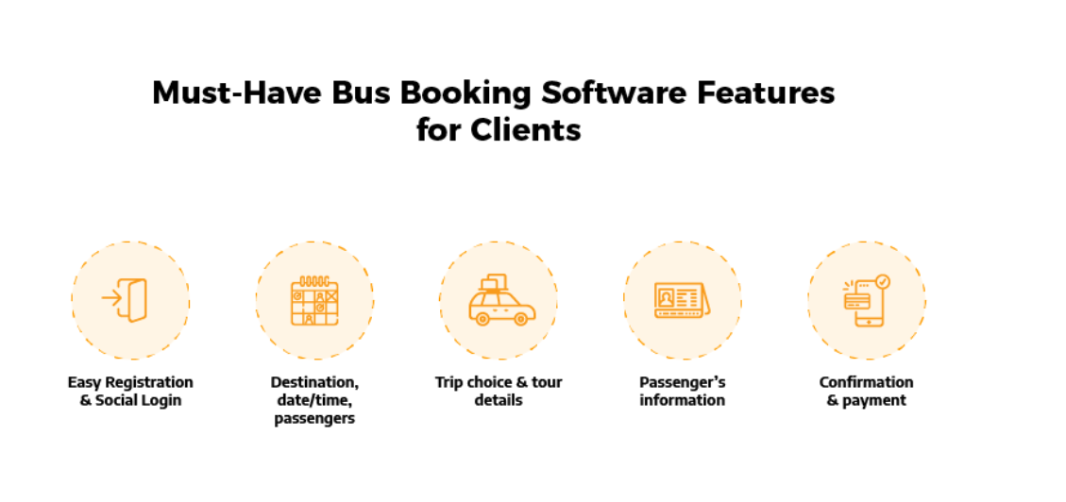

Must have bus booking Software business for Business-

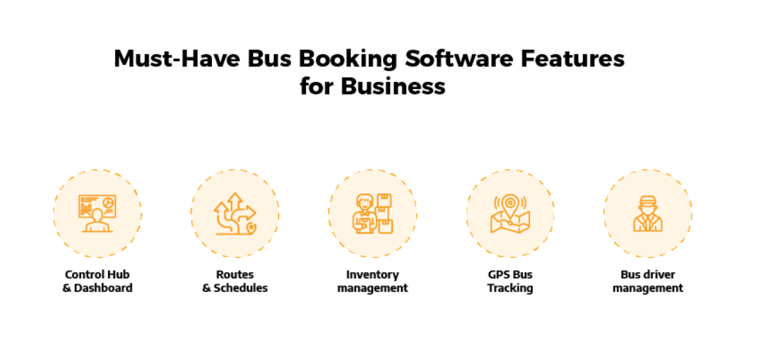

**Pritam Saha**

**ID:375**

1. User login: The login serves as the point for user login

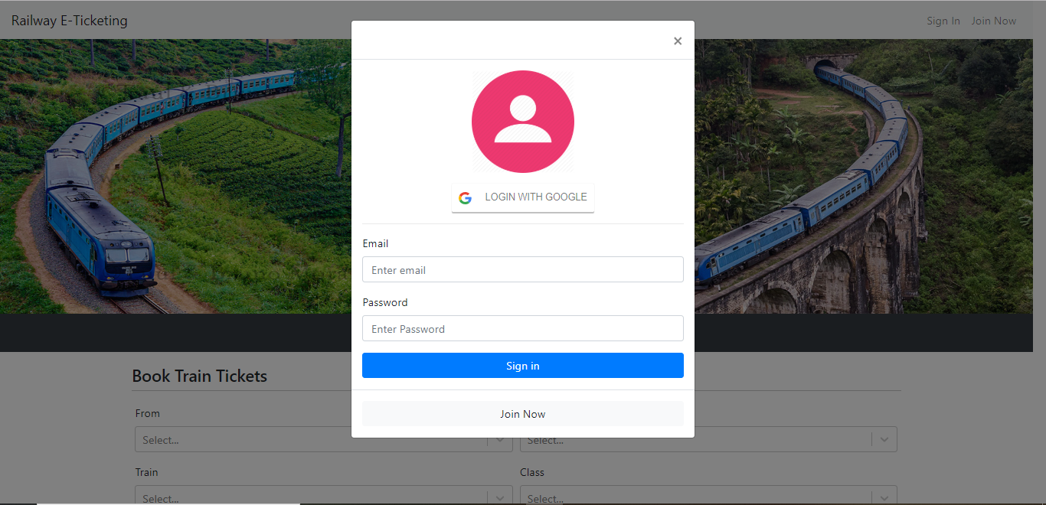

1. Registration

The registration serves as the point for user registration

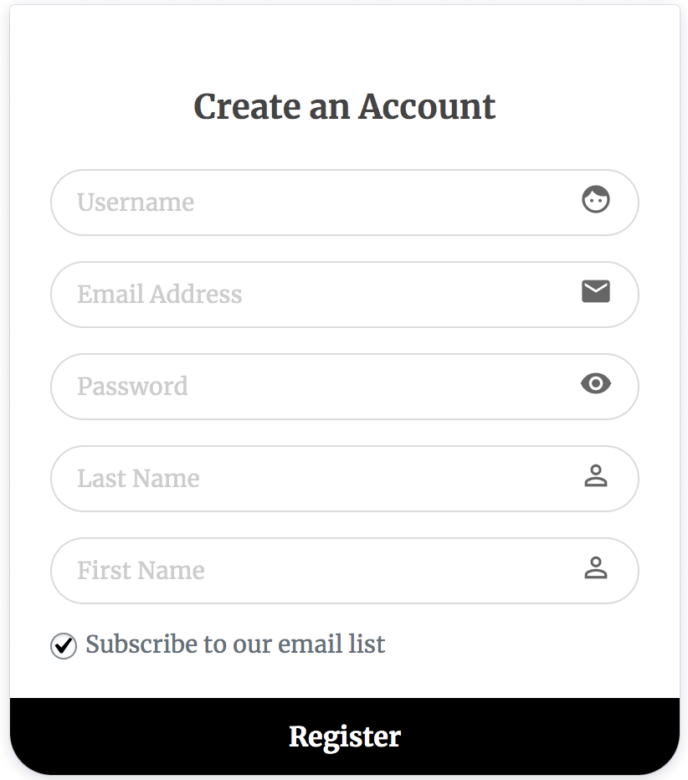

**Tama Shil**

**ID:342**

1. Components of the Interface:

* Home Page:

The home page serves as the starting point for users. Display available buses, routes, and search options prominently. Include a user-friendly search bar and clear navigation links.

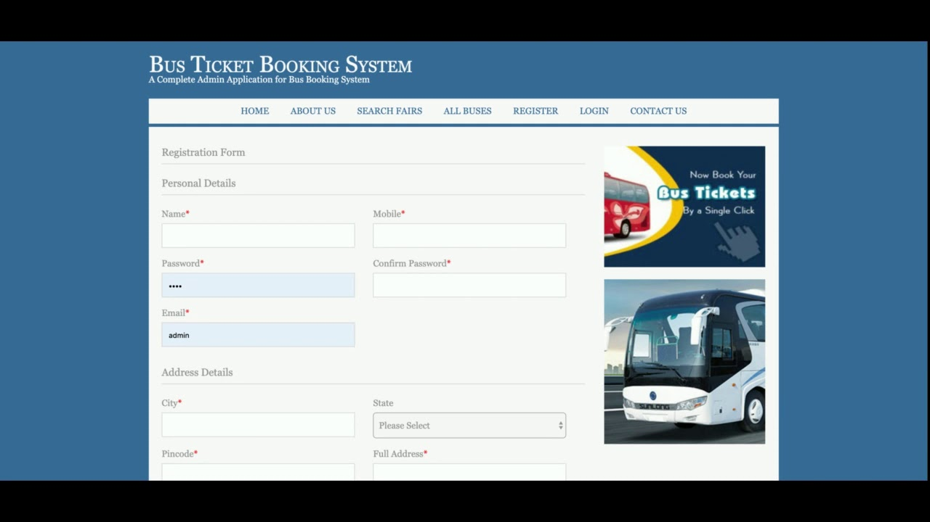

* Bus Details Page:

When a user selects a bus, present detailed information about the bus, including amenities, seat layout, and photos. Provide the option to choose seats and view available time slots.

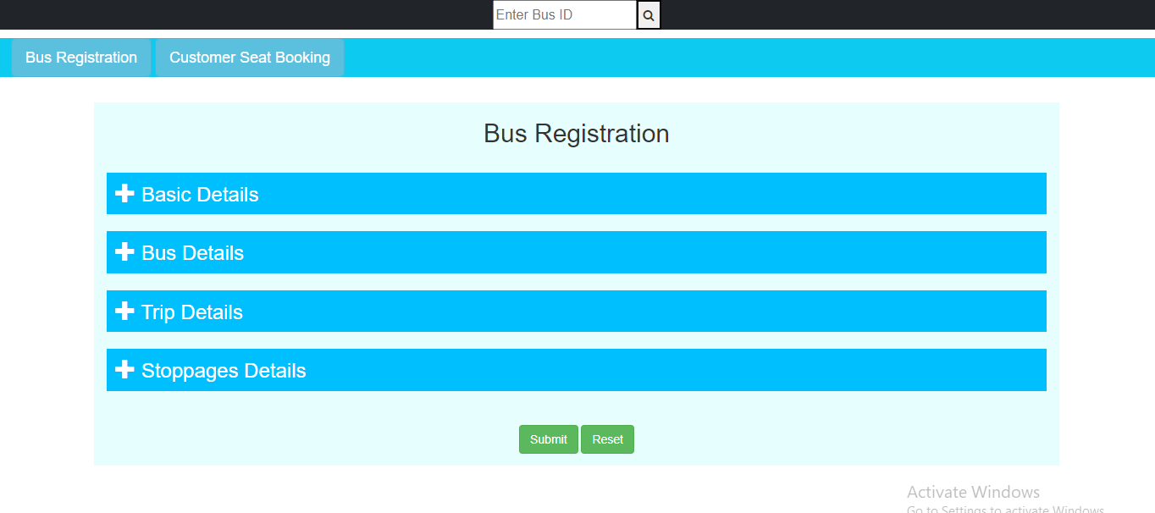

* Booking Process: Streamline the booking process. Clearly show available seats, allow seat selection, and prompt users to enter passenger details. Provide a summary of the booking before confirming.

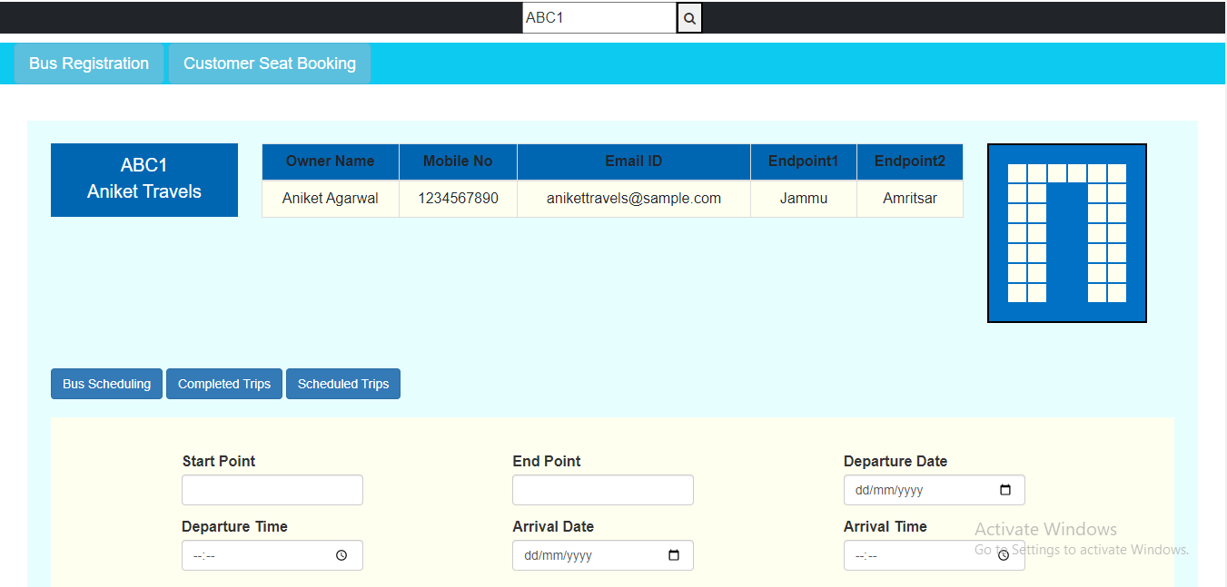

* Ticket Confirmation Page:

After booking, display a confirmation page with all relevant details, including seat numbers, departure time, and boarding point. Provide a printable or downloadable ticket.

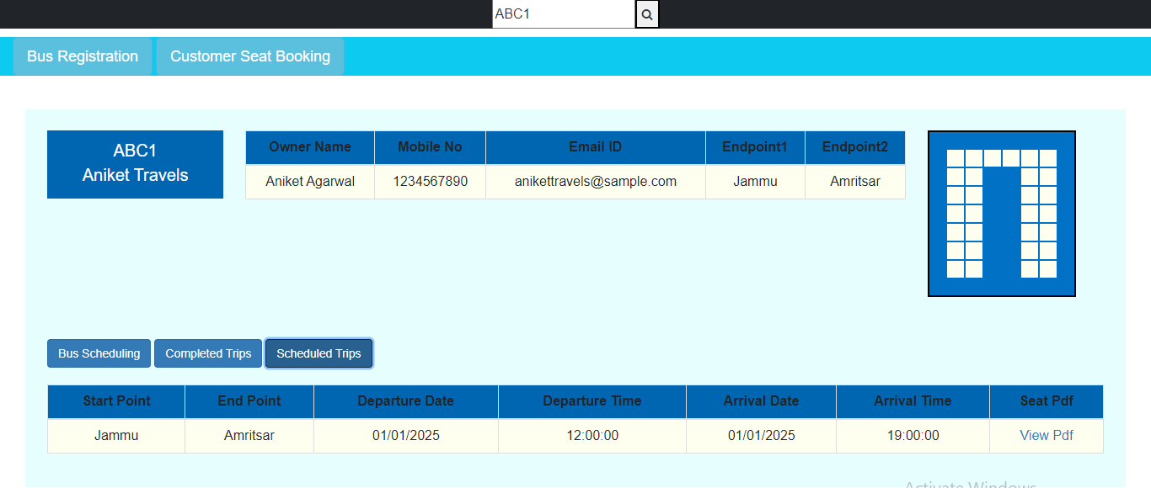

* User Dashboard:

Create a user dashboard where users can view their booking history, manage their profile, and access customer support if needed.

6. Conclusion:

Effective interface design is a blend of aesthetic appeal, usability, and functionality. In the context of an online bus ticket management system, a user-centric approach, adherence to design principles, thoughtful arrangement of components, and attention to visual elements contribute to a seamless and satisfying user experience. An intelligently designed interface enhances user engagement and contributes to the success of the application.



Course Code : CSE 404

Course Title : Software Engineering and ISD Laboratory

Project name : Bus ticket booking management system

Experiment no: 07

Experiment name: Application of design pattern (Interface) of bus ticket

**Submitted To**

**Dr. Mohammad Zahidur Rahman**

Professor

**Dr. Md. Humayun Kabir**

Professor

Department of Computer Science & Engineering Jahangirnagar University, Savar.

Group No : 02

Group members :

|  |  |  |
| --- | --- | --- |
| **Sl** | Class Roll | Name |
| 01 | 342 | Tama Shil |
| 02 | 370 | Prokash Maitra |
| 03 | 374 | Mubasher adnan jihad |
| 04 | 375 | Pritam Saha |